Safeguarding and Welfare Policy

At Lagan Valley Orienteers (LVO) we want you to feel safe and welcome. We encourage you to raise any concerns you have or incidents you witness at the earliest opportunity to our Club Designated Safeguarding Officer (Chloe Reed) or British Orienteering’s Lead Safeguarding Officer (Jeanette Downing).

LVO is committed to the principles of Safeguarding Children and Adults at Risk and our Club Designated Safeguarding Officer is always there if you need any support or would like any advice.

Everyone has a shared responsibility for safeguarding and creating safe, enjoyable environments in Orienteering, whether as an orienteer, parent, coach, club official or spectator.

Reporting a concern or incident

All reports are taken seriously and dealt with in a sensitive manner. Should you wish to report a concern or incident, please contact either:

- Our Club Designated Safeguarding Officer
  - Chloe Reed 07720 204216 LVO.safeguarding@niorienteering.org.uk
- British Orienteering’s Lead Safeguarding Officer
  - Jeanette Downing 07891 091622 safeguarding@britishorienteering.org.uk

This includes any concerns about safeguarding either within orienteering or outside of orienteering and any concern over adult behaviour related to the welfare of children or adults at risk, including those away from the sport that involves members or participants.
All reports will be logged in confidence with the Lead Safeguarding Officer who will also explain the processes which will be followed depending on each case.

Your Club Designated Safeguarding Officer

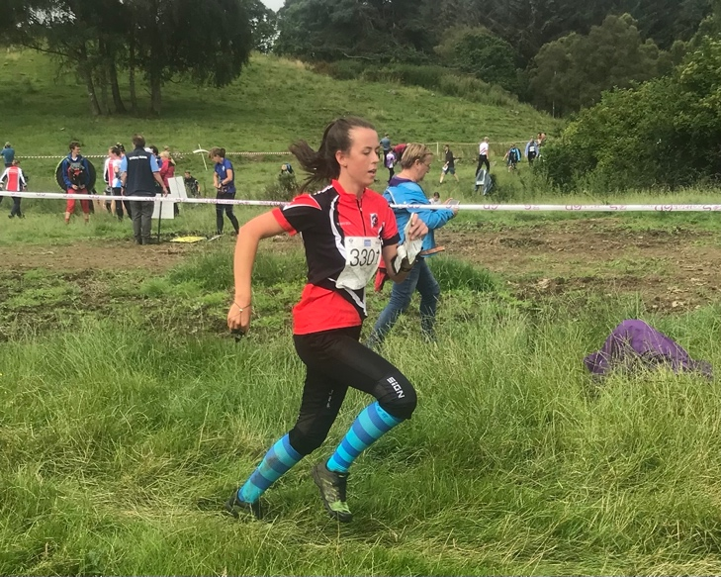

Hi, my name is Chloe and I am the Designated Safeguarding Officer for LVO and NI Orienteering. I started orienteering at a very young age with my family and still enjoy orienteering as a senior member of the club.

I have wide range of experience in safeguarding and am really pleased to be able to fulfill this important role in ensuring that children feel safe and happy while they are orienteering with our club.

Reporting Forms

In addition to contacting the LVO Safeguarding Officer or Lead Safeguarding Officer, British Orienteering has introduced a quick report form which can be used to make immediate reports to the Lead Safeguarding Officer. This form is user friendly on mobile devices.
On completion of this form the Lead Safeguarding Officer will follow up with you directly.
Other Reporting Forms (MS Word version)
- Incident reporting form children and young people
- Incident reporting form adults
If you complete one of these forms, it will then need to be emailed to either our Club Safeguarding Officer or the Lead Safeguarding Officer as soon as possible.
If you need any advice on how to complete a form or what should you do if someone reports something to you, this short video will help you.

Safeguarding Policies

As a club, we support and follow British Orienteering’s two safeguarding policies, these can be found via the links below:

- Child Safeguarding Policy
- Safeguarding Adults at Risk Policy

For further information including resources and training opportunities visit the British Orienteering website or contact the Lead Safeguarding Officer.

What you can expect from us
When you bring your children orienteering we will help you to ensure their welfare and safety by ensuring that;
- The people who run the sport are safe to be with.
- We take all reasonable steps to ensure that your children will be safe from other participants and strangers.
- The challenges set will be manageable so that your children are able to find their way around the course.
- They are not likely to be injured but if they are there are people and procedures in place to look after them.
- Your children’s individual needs will be considered as far as possible within the nature of the sport.
The people who run the sport are safe to be with:
Our coaches and officials who have unsupervised regular contact with children and adults at risk have satisfactory Access NI checks.
Our club has a safeguarding officer.
We take all reasonable steps to ensure that your children will be safe from other participants and from strangers:
Organisers of events and activities carry out risk assessments and have procedures for managing safety in public places.
We have had no reported incidents of children coming to any harm from strangers in public places whilst orienteering.
The challenges set will be manageable so that your children are able to find their way back, the ground they cross is not too rough for their experience/strength:
Planners of courses and activities follow rules and guidelines to provide courses or activities with different levels of challenge to meet different needs.
We keep track of every individual at every event or activity to ensure that they are accounted for. We will give you information so that you understand the level of challenge on courses offered.
We expect you to follow our guidelines about which course is appropriate for you or your children to complete. In order to meet our safeguarding and insurance responsibilities, we may refuse to let you do a course if we consider you are taking undue risk.
They are not likely to be injured but if they are there are people and procedures in place to look after them:
Officials organising events and activities carry out risk assessments.
They have procedures for finding and looking after lost children and for providing first aid.
Your children’s individual needs will be taken care of as far as possible within the nature of the sport:
At events, we will explain what physical and navigational skills are needed to complete a course and how we can help with an individual need.
At activities led by coaches if you tell us about any special needs we will tell you what adaptations can be made to make our activities accessible.

Date adopted: 3 September 2025

Our safeguarding policies are under constant review and will be amended to meet changing needs.

