Safeguarding Children and Adults at Risk Policy

At Lagan Valley Orienteers (LVO) we want you to feel safe and welcome. We encourage you to raise any concerns you have or incidents you witness at the earliest opportunity to our Club Designated Safeguarding Officer (Chloe Reed) or British Orienteering’s Lead Safeguarding Officer (Peter Brooke).

LVO is committed to the principles of Safeguarding Children and Vulnerable Adults and our Club Designated Safeguarding Officer is always there if you need any support or would like any advice.

Everyone has a shared responsibility for safeguarding and creating safe, enjoyable environments in Orienteering, whether as an orienteer, parent, coach, club official or spectator.

Reporting a concern or incident

All reports are taken seriously and dealt with in a sensitive manner. Should you wish to report a concern or incident, please contact either:

- Our Club Designated Safeguarding Officer
  - Chloe Reed 07720 204216 LVO.safeguarding@niorienteering.org.uk
- British Orienteering’s Lead Safeguarding Officer
  - Peter Brooke 07540 150963 safeguarding@britishorienteering.org.uk

This includes any concerns about safeguarding either within orienteering or outside of orienteering and any concern over adult behaviour related to the welfare of children or adults at risk, including those away from the sport that involves members or participants.
All reports will be logged in confidence with the Lead Safeguarding Officer who will also explain the processes which will be followed depending on each case.

Your Club Designated Safeguarding Officer

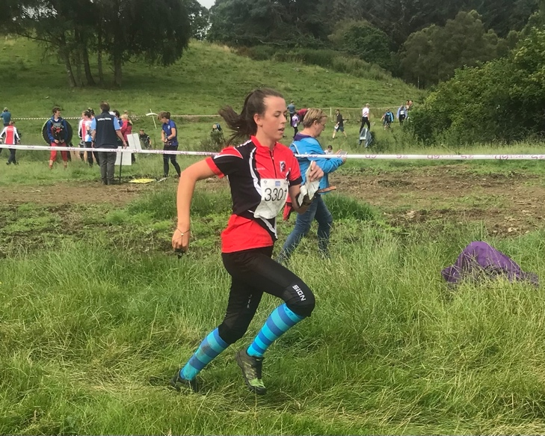

Hi, my name is Chloe and I am the Designated Safeguarding Officer for LVO and NI Orienteering. I started orienteering at a very young age with my family and still enjoy orienteering as a senior member of the club.

I have wide range of experience in safeguarding and am really pleased to be able to fulfill this important role in ensuring that children feel safe and happy while they are orienteering with our club.

Reporting Forms

In addition to contacting the Club Designated Safeguarding Officer or Lead Safeguarding Officer, British Orienteering has introduced a quick report form which can be used to make immediate reports to the Lead Safeguarding Officer. This can be accessed here. This form is user friendly on mobile devices.

Safeguarding Policies

As a club, we support and follow British Orienteering’s two safeguarding policies, these can be found via the links below:

- Child Safeguarding Policy
- Safeguarding Adults at Risk Policy

What you can expect from us
When you bring your children to our orienteering events, we will help you to ensure their welfare and safety by ensuring that;
- The people who run the sport are safe to be with.
- We take all reasonable steps to ensure that your children will be safe from other participants and strangers.
- The challenges set will be manageable so that your children are able to find their way around the course.
- They are not likely to be injured but if they are there are people and procedures in place to look after them.
- Your children’s individual needs will be considered as far as possible within the nature of the sport.

Date adopted: 5th June 2023

Our safeguarding policies are under constant review and will be amended to meet changing needs.

