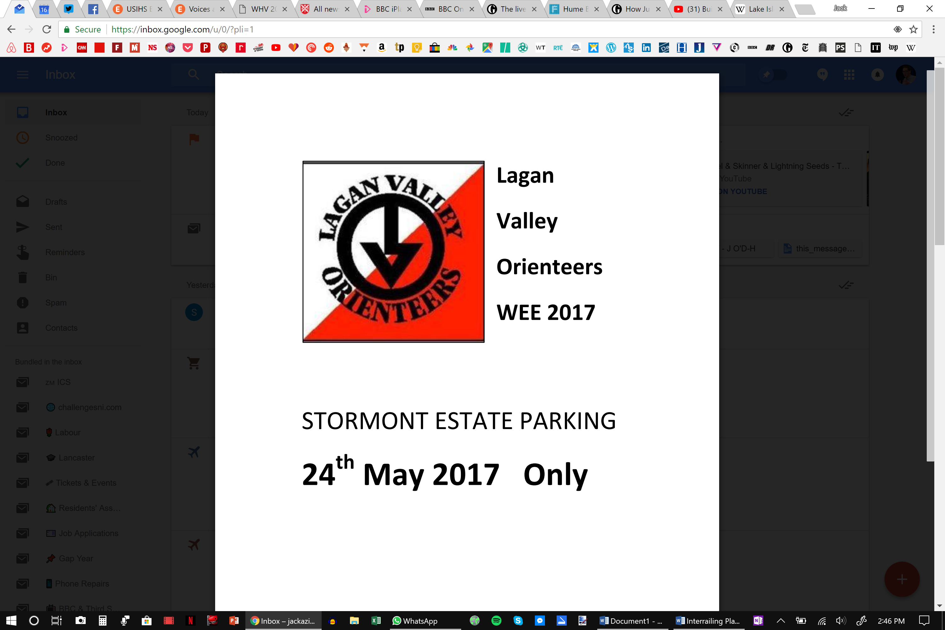

**23rd MAY 2018**

**WEE 2018**